**E-Commerce Sales Dashboard**

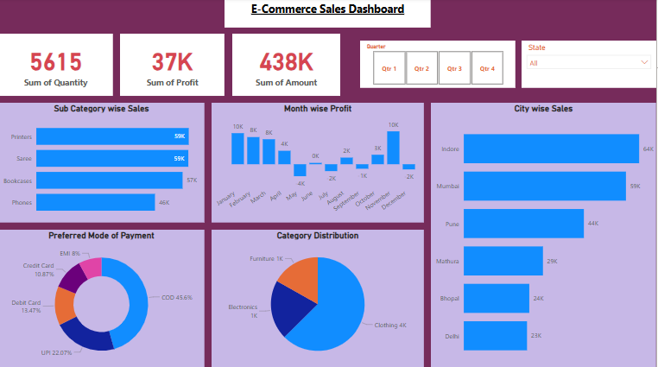

This is E-Commerce Sales Dashboard where I have analysed data by Using graph, slicer and cards.

Here I have analysed-

**Sub-Category wise Sales** where I have used filter to show top Sub-Category.

The analysis shows that Printer, Saree, Bookcases, Phones falls under top Category

**Month wise Profit** here, the analysis shows that January & November are the month where there is highest sales and May, July, September falls under loss which need to be focused more.

**Preferred Mode of Payment,** it shows that what is the mode of payment of customers & outcome for the same is that customers prefers COD(Cash On Delivery) more.

**City Wise Sales** as shown in the graph Indore, Mumbai, Pune are the top 3 cities where the sales is high, the reason behind the same might be that these are tier 1 cities. To show the top cities I have used filter.

Apart from these graphs I have also attached the Cards which shows **Sum of Quantity, Sum of Profit, Sum of Amount/Sales.**

And to filter data on such criteria like Quarter wise data & State wise data I have used slicer which made filtration easy based on few criteria.